

Virtual Conference Access
April 2016-17
Registration Instructions
- Please visit the OLC International Conference Registration Page.
- Select "Register - Virtual".
- Add to cart "Innovate Virtual Individual Attendee". Select “Check Out”.
- “Create Account” and fill in your name, title, email address, password, and interest field. Select “Agree to terms and conditions”. Check “I’m not a robot”. Select “Sign In”.
- You will be taken to My Dashboard.
- Select your organization. Type in “Texas A&M University-Commerce”.
- Fill in remaining fields on your profile: position category, job title, department, etc. Select “Update Profile”.
- Select “Shopping Cart”. Select “Check Out”.
- Enter discount code provided below to complete your purchase with a zero ($0.00) balance: CODE: 2016-INNOV-VIRT-UGPNPFQXMKMHZ2E
- Fill out billing information.
- Select “Apply to Order”. Tip: Do not wait for the code to apply. Scroll to bottom and click “Review your order”.
- Verify the purchase amount of $0.00. Select “Submit order”.
- You will be taken to My Dashboard.
- You will receive an email to confirm your registration, which will include the virtual access instructions and the link to access the OLC Innovate 2016 sessions.
- You are now registered and may view any recorded session up to 1 year post-conference (or until April 19, 2017).

OLC Innovate 2016 Sessions
Browse the Streamed Session listing and select the title of the session you wish to view. The recorded session and session materials, if available, may be accessed by clicking on the orange buttons on each session page.
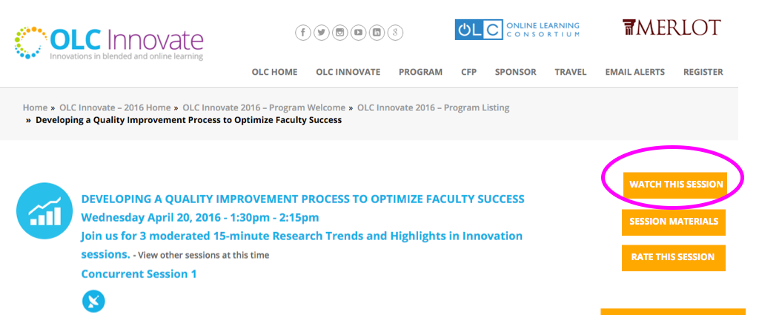
Toubleshooting Tips
- Log in to the OLC conference website with your free user account. You will see in the upper right hand corner of your screen “You are logged in as username”.
- Next, be sure you have Microsoft Silverlight installed on your system. Download a free version here.
- We use Sonic Foundry’s MediaSite player which requires Silverlight. Test MediaSite Now.
- Please be sure that your internet connection is working. We recommend that you use Chrome, Firefox, Safari, or any Internet Explorer version 9 or higher.
- If you have any questions, refer to the FAQ page.
- If you still need technical assistance, please email us at support@onlinelearning-c.org.

