To Upload a PDF Version of Course Syllabus

In order to upload a PDF version of the course syllabus, the current Pearson LearningStudio (eCollege) syllabus item needs to be disabled in the course. The Pearson LearningStudio (eCollege) syllabus item only allows for Word documents to be uploaded. The formatting of the Word version often does not hold causing the syllabus to appear unformatted.

First the Pearson LearningStudio (eCollege) Syllabus item under Course Home must be “Disabled.”

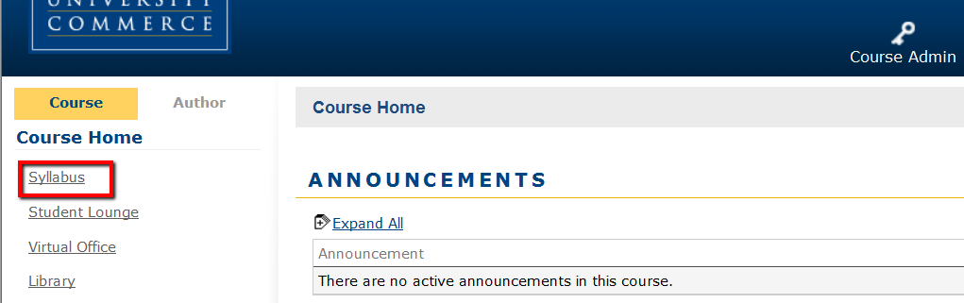

1. Click on Course Admin, and then click on Enable/Disable Tools.

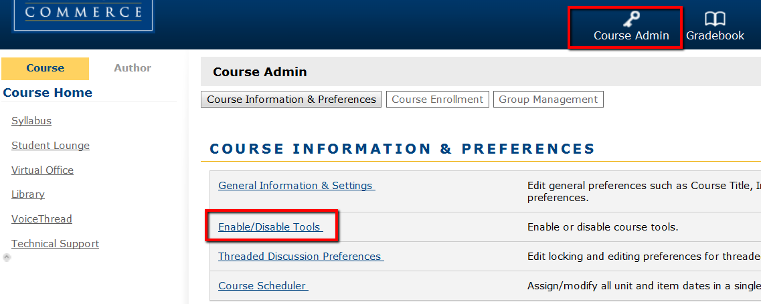

2. Click the Disable radio button to the right of the word Syllabus and click the Save Changes button.

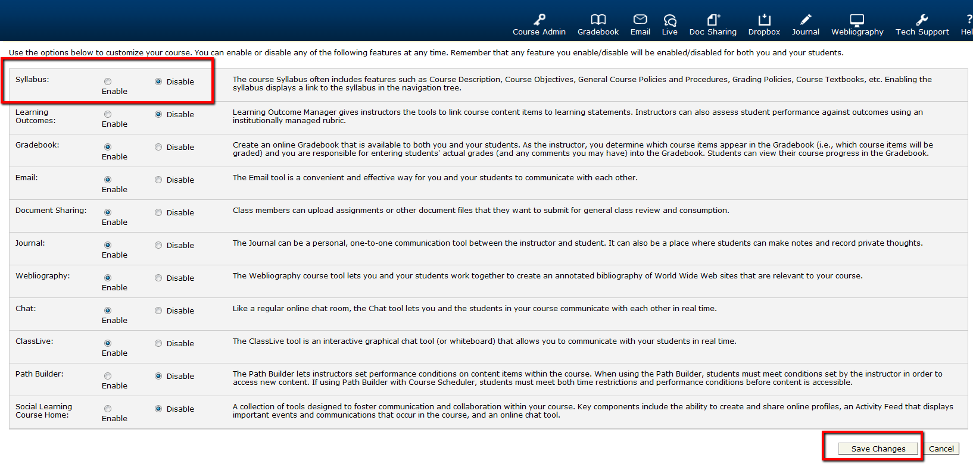

3. The Syllabus item is no longer visible under Course Home.

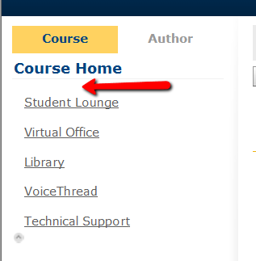

Second, a Syllabus item, that allows for PDF’s to be uploaded, needs to be created under Course Home.

1. Click on Course Home, and then click on Author Mode, and then click on Course Items.

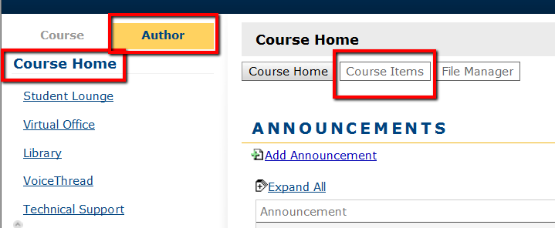

2. In Course Items, click on Add Items

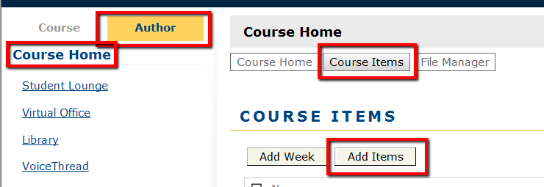

3. In the Add Items window:

- Enter the name of item type TAMUC Syllabus to differentiate it from the Pearson
LearningStudio (eCollege) version of the syllabus.

- In the Item type box, select Web Content Upload, this option allows for PDF documents to be uploaded into the TAMUC Syllabus item.

- Insure that Course Home is highlighted in the Add to: box.

- Click the Add Items button.

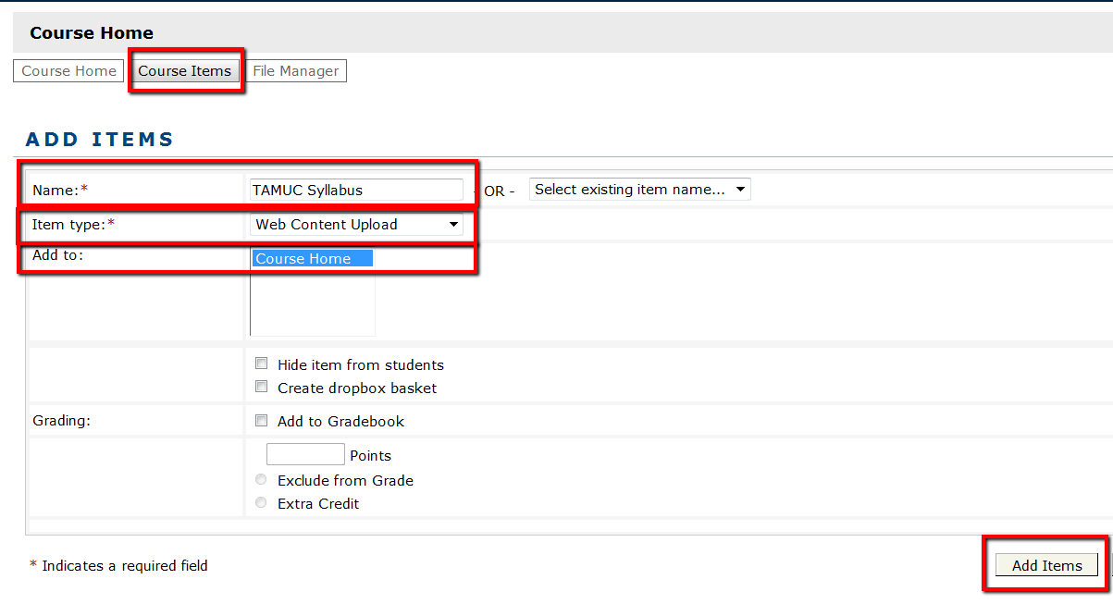

4. The TAMUC Syllabus item appears as the last item under Course Home. To Move the TAMUC Syllabus item to the top of list under Course Home:

a. In Author Mode, click on the item TAMUC Syllabus.

b. Click on Toolbox.

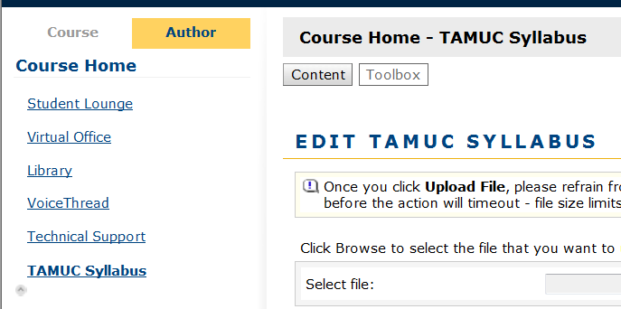
5. To Move the TAMUC Syllabus item to the top of the list under Course Home, in the Toolbox, click on Move TAMUC Syllabus.

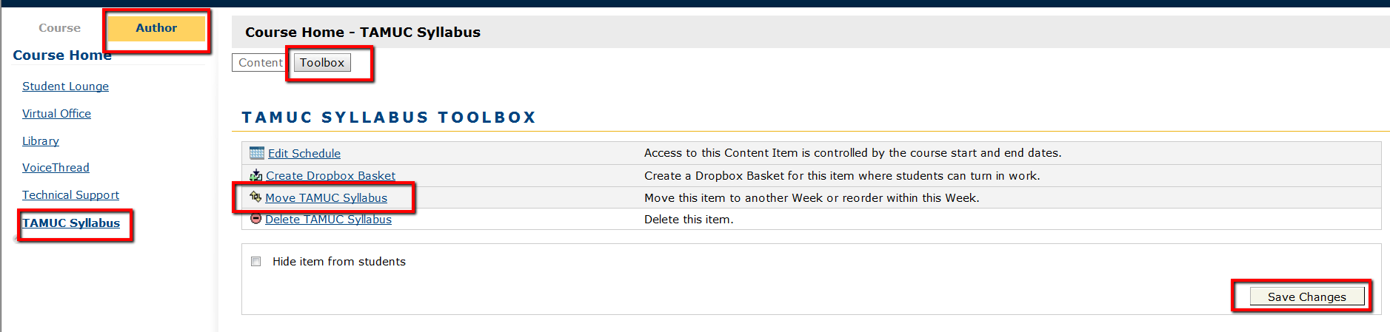

6. Put the number 1 in the box to the right of the TAMUC Syllabus item. Change the number of the other items to your preferred order. Click Save Changes.

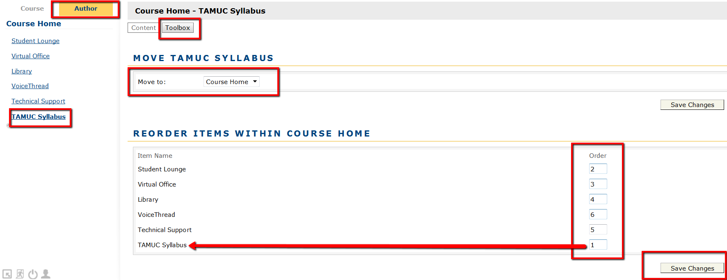

7. Now, a PDF version of the course Syllabus can be uploaded. Click Browse to find the PDF version of the syllabus. After the item is selected, click the Upload File button.

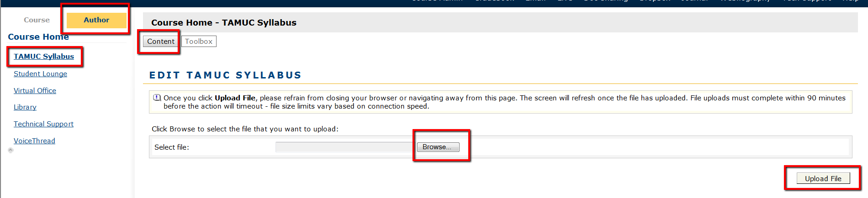

8. The Word version of the syllabus must be saved as a PDF. With the syllabus Word document open, click on File, click on Save as Adobe PDF.

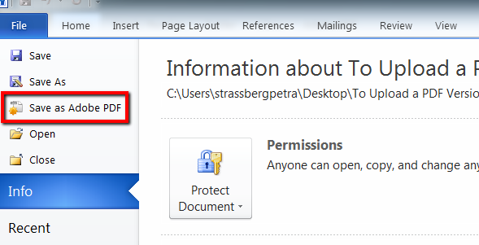

9. Now upload the PDF version of the Syllabus to the TAMUC Syllabus item under
Course Home in the course.

***To meet Accessibility requirements upload a copy of the Word version of the Syllabus to DocSharing or have a link that takes the student to a Word version of the syllabus. **

