Irresponsible Choices: The Professional Consequences

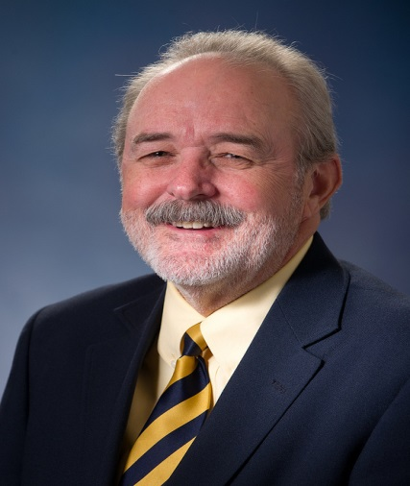
Jay Garrett, J.D.
University Lawyer

Do you know the financial and legal ramification of a drug or alcohol arrest and how it will affect the rest of your personal and professional life?
Sponsored by: AOD Task Force
April 9, 2014
6 pm
RSC- Conference Room A

Free T-Shirt to the first 200 students

