
Writing a Paper?
FREE tutoring in writing for all TAMU-C students.

All majors and writing levels!

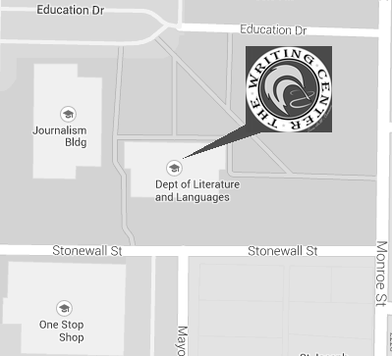
Call to schedule an appointment: 903-886-5280 or Walk-In
Visit us at The Writing Center to discuss your needs with a tutor about:
-Understanding a Prompt
-Brainstorming and Organizing a Paper
- Researching Scholarly Sources
-Formatting Your Paper (APA, MLA, Chicago)
-Editing for Correct Grammar and Punctuation

You can also submit your paper online at writing.tamuc@gamil.com
Like us on Facebook at www.facebook.com/TAMUC.Writing
“The difference between the right word and the almost right word
is the difference between lightning and a lightning bug.” – Mark Twain

Writing Lab Hours

Hall of Languages 103
Monday 9am – 4pm
Tuesday 9am – 4pm
Wednesday 9am – 4pm
Thursday 9am – 4pm
Friday 9am – 1pm

Gee Library (2nd Floor)
Monday-Thur. 10-4pm
Friday By Appt. Only
Sun./ Wed. 6-8pm
Mon./ Thur. 6-9pm

