1. Log in to MyLEO (https://leo.tamu-commerce.edu/Main.aspx) and go to Faculty Apps section.
rick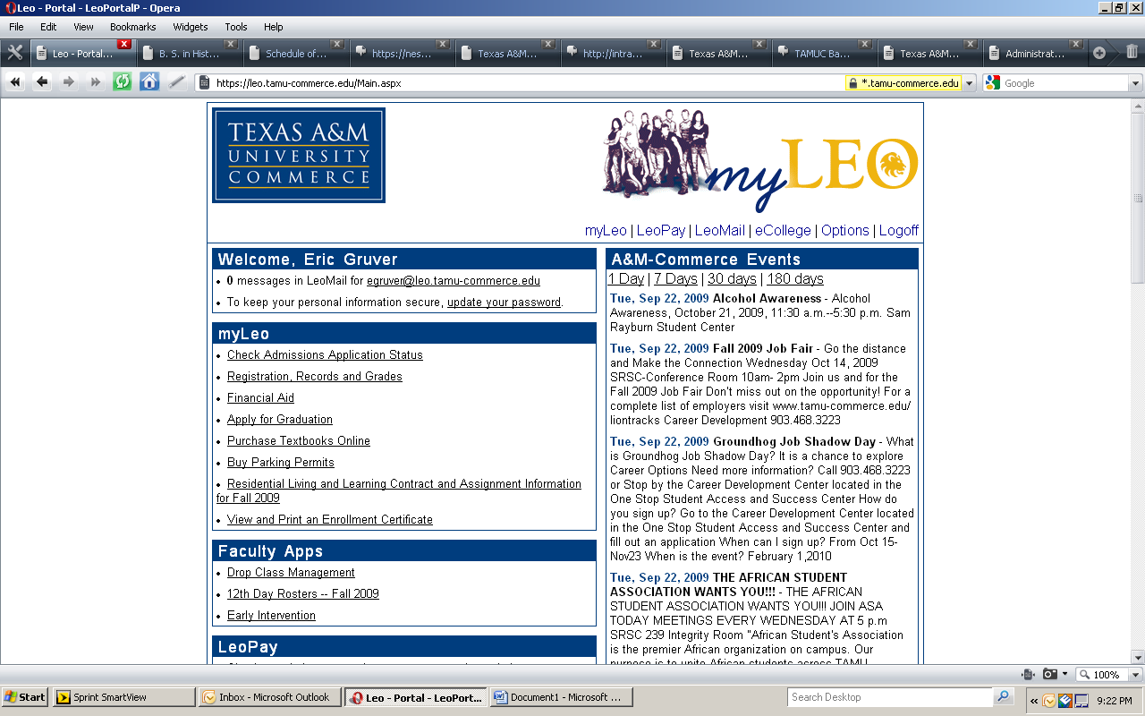
2. Click the Early Intervention link. Each course that you teach with freshmen enrolled should show up here.
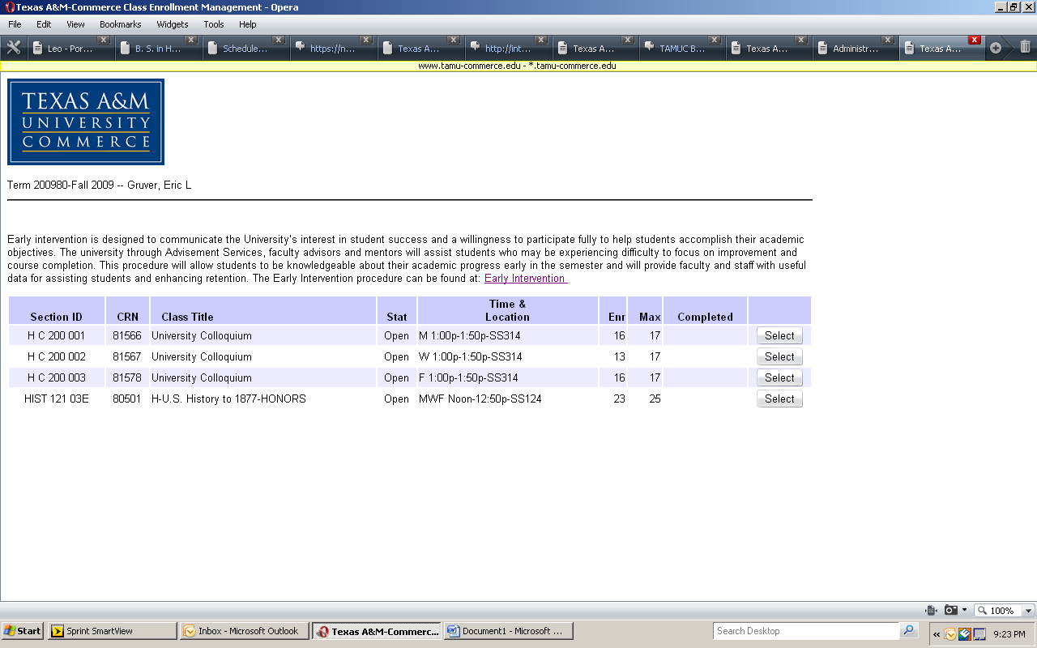
3. Click on select for each course and complete the attendance and grade information for each student.
The needs referral box is to be used to indicate students who might have behaviors or other indicators that might warrant them needing intervention besides attendance or grades (e.g. sleeping in class, using a cell phone during class, not bringing required materials, etc.) The comments section can be used to provide additional information to be used by University College in working with identified students.

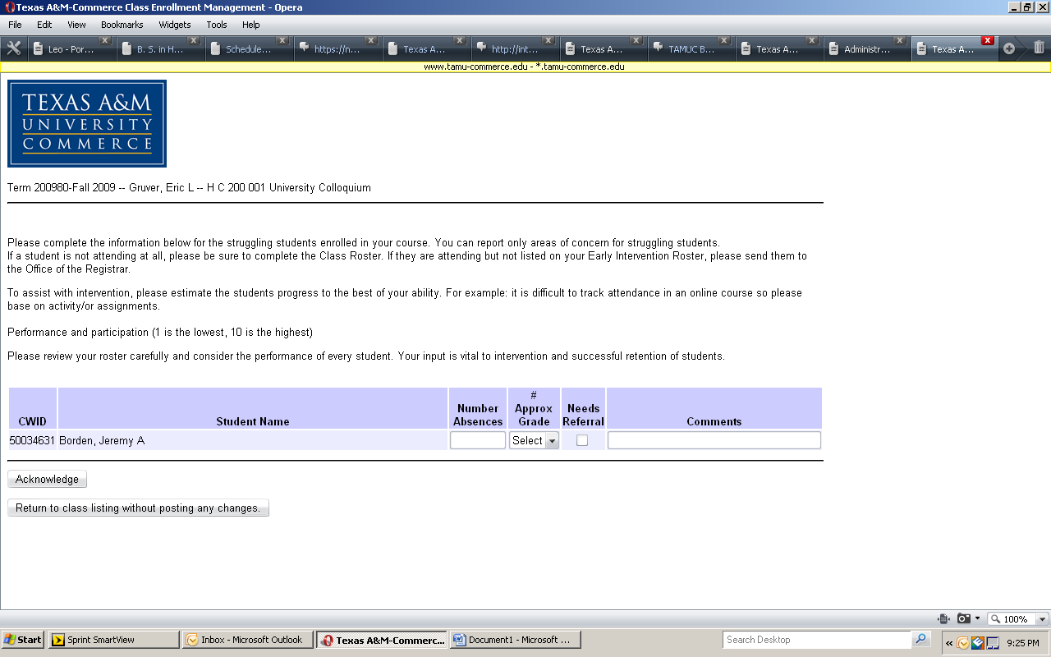
4. When all information is entered, click the ACKNOWLEDGE button at the bottom of the page and proceed to next class or exit MyLEO.

