Commerce Leadership Institute- Class of 2018
Bois D’ Arc Bash Volunteer Form
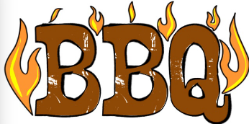
Thursday, September 20th – Friday, September 21st

Name: _________________________________________________
Phone Number: __________________________________________
Email: __________________________________________________
Availability: ______________________________________________
Number of hours desired: ___________________________________
Shift Example: Food runers, food delivery, brisket cutters, sack stuffers
*Two and Three Hour Shifts Available at First Baptist Church in Downtown Commerce

Two Hour Shifts | Thursday, Sept 20 | Friday, Sept 21st |  | Three Hour Shifts | Thursday, Sept 20th | Friday, Sept 21st
8:00 - 10:00 am |  |  |  | 8:00 - 11:00 am
10:00 am- 12:00 pm |  |  |  | 11:00 am- 2:00 pm
1:00 - 3:00 pm |  |  |  | 12:00 pm - 3:00 pm
3:00 - 5:00 pm |  |  |  | 2:00 - 5:00 pm
5:00 - 7:00 pm |  |  |  | 3:00 - 6:00 pm
7:00 - 9:00 pm |  |  |  | 6:00 - 9:00 pm

Commerce Leadership Institute (CLI) promotes community involvement and civic leadership. The class meets twice a month for ten sessions during the spring, wherein class members visit local businesses, schools, the university, and various city facilities to get a broader understanding of the City of Commerce. The CLI Class of 2018 concludes their training with a BBQ fundraiser in conjunction with the Bois d’Arc Bash on Friday, September 21st. In addition to being a substantial team-building exercise for the current CLI class members, proceeds from the barbecue help to assure that the CLI program will continue for future student participants.

Please send forms/questions to Molly.Jacobsen@tamuc.edu or drop off at City Hall (1119 Alamo St. Commerce, TX 75428).

