1st Annual Texas A&M University—Commerce Benefit Powwow Saturday, November 8, 2014
Noon to 9:30pm Sam Rayburn Student Center Commerce, Texas 75429 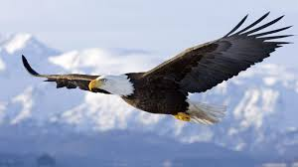

Proceeds benefit the Albert S. Old Crow Scholarship

Arts & Crafts, Cake Walk, Contest Dancing, Food, Raffles, 50/50
*Veterans Honor Ceremony*

All Veterans, Color Guards, Gourd Dancers, Drums, and Princesses Welcome
For more information: contact :
Powwow@tamuc.edu
Facebook: Texas A&M University—Commerce Powwow
Twitter: @TAMUCPowwow

Master of Ceremonies: Albert Old Crow
Arena Director: Harold Rogers
Head Man Dancer: Scott Henninger
Head lady Dancer: Polly Davis
Head Gourd Dancer: Byron Komah
Northern Drum: Young buffalo Horse
Southern Drum: Bearclaw
Storyteller/flute: William Harjo
Color Guard: Renegade Nation
Assisted by the Naval ROTC unit of Greenville HS

NO DRUGS, FIREARMS, or ALCOHOL PERMITTED ON THE PREMISES
Not responsible for theft, lost or stolen items

For more information:
Noah Nelson, Office of the President: Noah.Nelson@tamuc.edu
Terryl Bratek, Event Coordinator: Powwow@tamuc.edu
Facebook: Texas A&M University—Commerce Powwow
Twitter: @TAMUCPowwow

