Virtual Student Organization Fair Instructions
1. If you signup for a booth your organization ManeSync page administrators will receive a notification in their ManeSync. You can find notifications under the initial menu and then click on notifications.
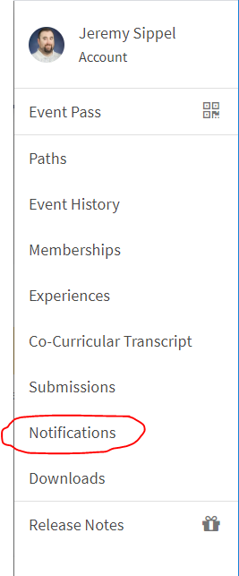

2. In your notifications there will be a notification that says “Register Your Organization in ManeSync’s Virtual Fair! Click on the notification.
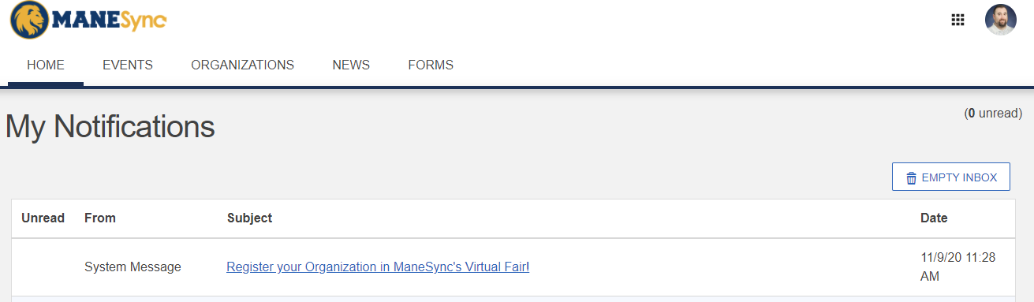

3. On the next page there will be a message with instructions and a link with your organization’s name. Click on your organization’s name.
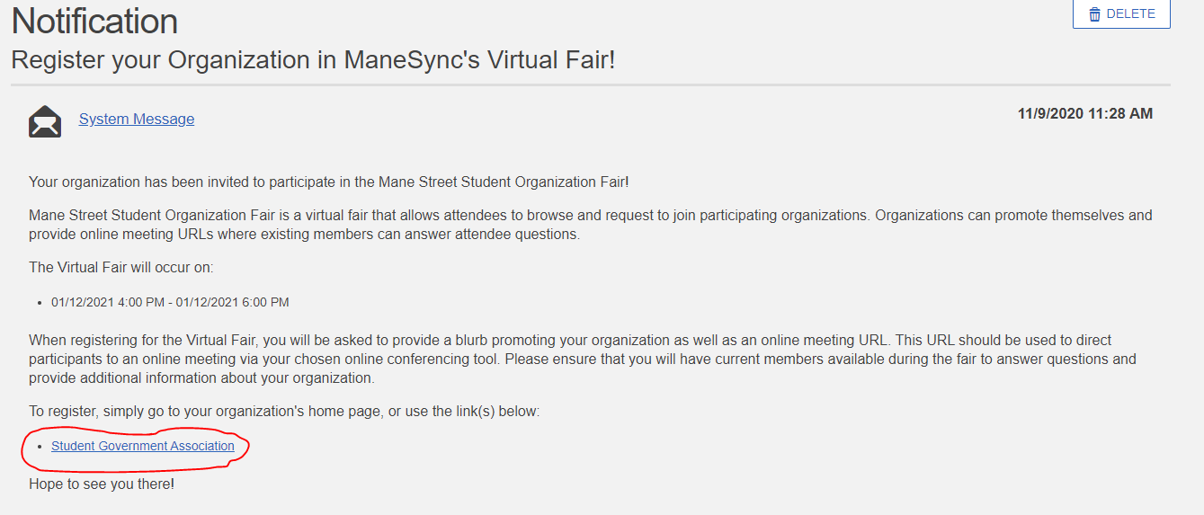

4. On the next page, click on the blue “sign up” button.
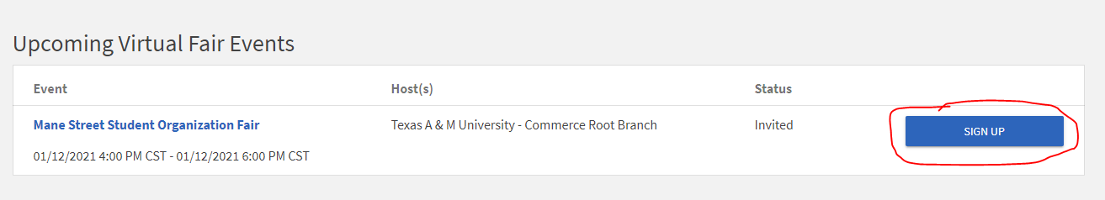

5. The next page will be for you to complete “about” your organization and provide a URL link for either Zoom, Microsoft Teams, Discord, WebEx, etc., any virtual online meeting platform you use. Once you have completed that form, click submit, and you will be added into the fair.
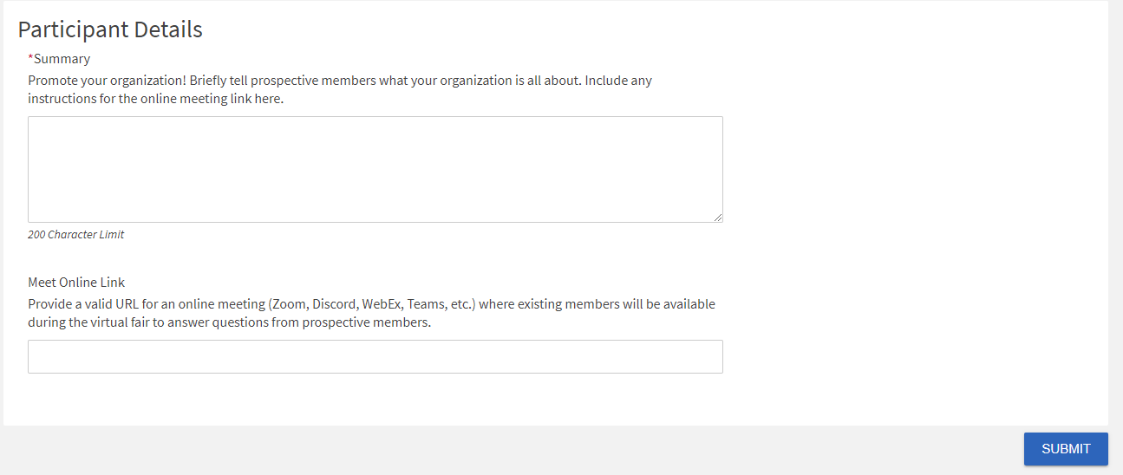
6. On the day of the fair, all you will need to do is login to the URL link that you provided in the signup. Students will be able to see the URL link you’ve provided and click on the link to join your booth.

