
Dear Texas A&M-Commerce Student Organizations: February 22, 2018
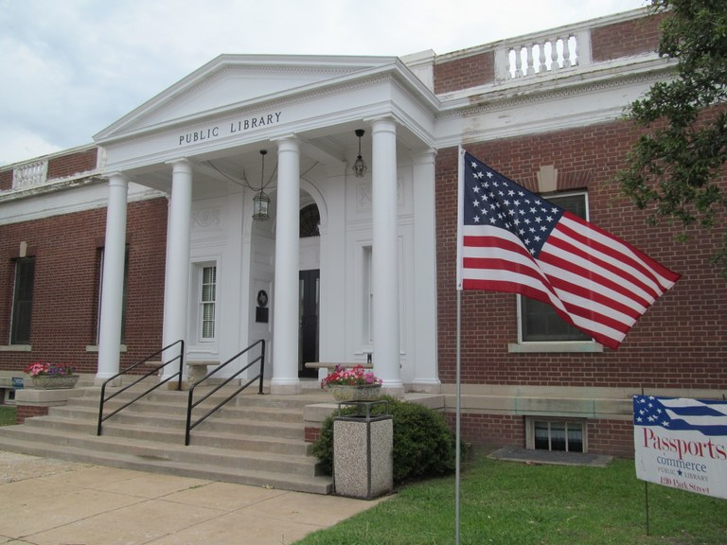
As spring approaches, the Commerce Public Library approaches its centennial. Originally built as a post office, groundbreaking for the Commerce Public Library building was in July, 1917 and it was ready for occupancy on August 15, 1918. But now the library needs your help to preserve its architectural and historic value.
Help restore this beautiful old building!
The pictures below illustrate the extreme state of disrepair of the parapet in contrast with the recent restoration of the portico. There are 122 spindles on the building. With each spindle donation of $400, a section of the entire parapet wall and cornice will be restored. And your organization will receive naming rights to that spindle.
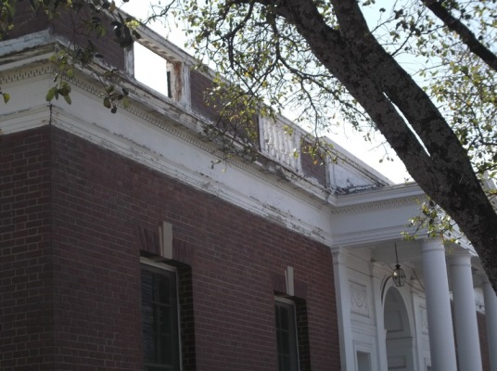
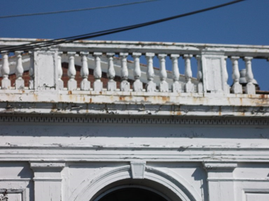

A gift of $400 will associate your organization’s name with one of the spindles. However, a contribution in any amount is welcome.
To make a tax-deductible contribution, please send a check payable to the Commerce Public Library and mail it to: Commerce Public Library, 1210 Park Street, Commerce, Texas 75428. If you have questions, please direct them to Nan Clay by email at: director@commercepubliclibrary.org or by calling (903) 886-6858.

