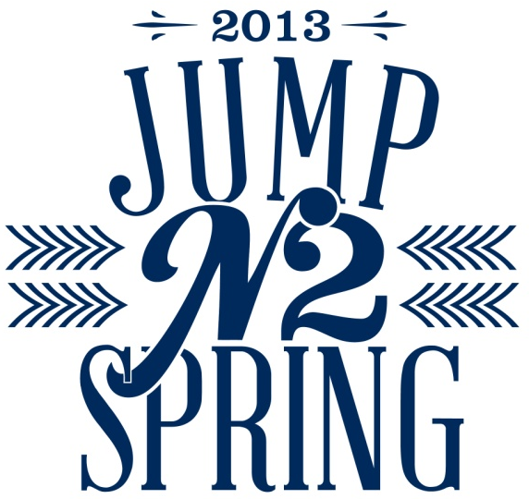

Student Organization Booth Form
If your organization would like host a booth at our annual Jump N2 Spring event on Thursday, Jan 17th, please fill out the form below. You will need to have 2-3 representatives to stay at the table at all times. Set up time is 6:15pm, and the event is from 7-9pm. You will be on the track above the gym and you may bring your letters. The status of your organization will be checked with the University.

…………………………………………………………………………………………………
*Forms are due on Jan 16th with the Business Center at the MRC by 7pm.
Organization/Department: ________________________________________
Organization Advisor: ____________________________________________
Contact Person #1: _______________________________________________
Phone Number: _________________________________________________
Contact Person #2: ______________________________________________
Phone Number: _________________________________________________

We will provide a table and table cloth. Please bring and information to represent your organization! Be aware that hosting a table does not guarantee you a shirt or any prizes; you must partake in all activities to receive a shirt.
If you have any questions please send an email to sarah.cunningham@tamuc.edu

