
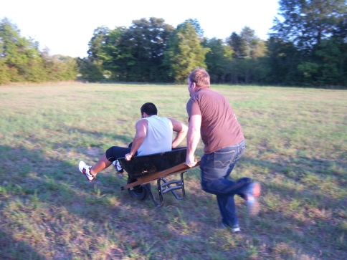
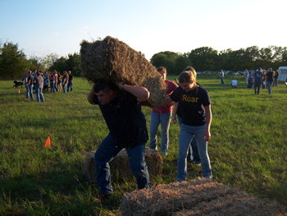
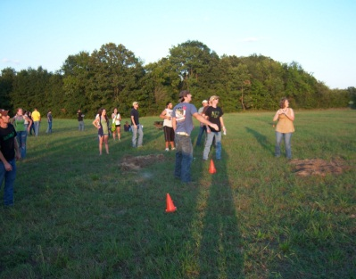
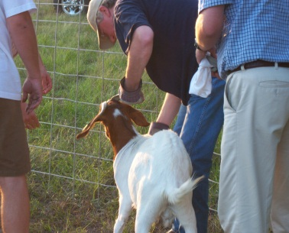

When: March 24, 2011

Time: 5:00 P.M.

Where: AGR House (Blueberry Farm)

Registration: Teams of 4
Register by March 22, 2011

Email: DPerry@leo.tamu-commerce.edu

Prizes: Awards will be given to the top 3 teams

The farm is located at 2965 State Highway 50, 5.5 miles north of I-30.

Events include
- Goat Dressing

- Hay Bale Relay

- Steering Wheel Toss

- Wheel Barrow Race

- Dizzy Roping

Please Carpool!!!

Agricultural Olympics
Sponsored by Alpha Gamma Rho

