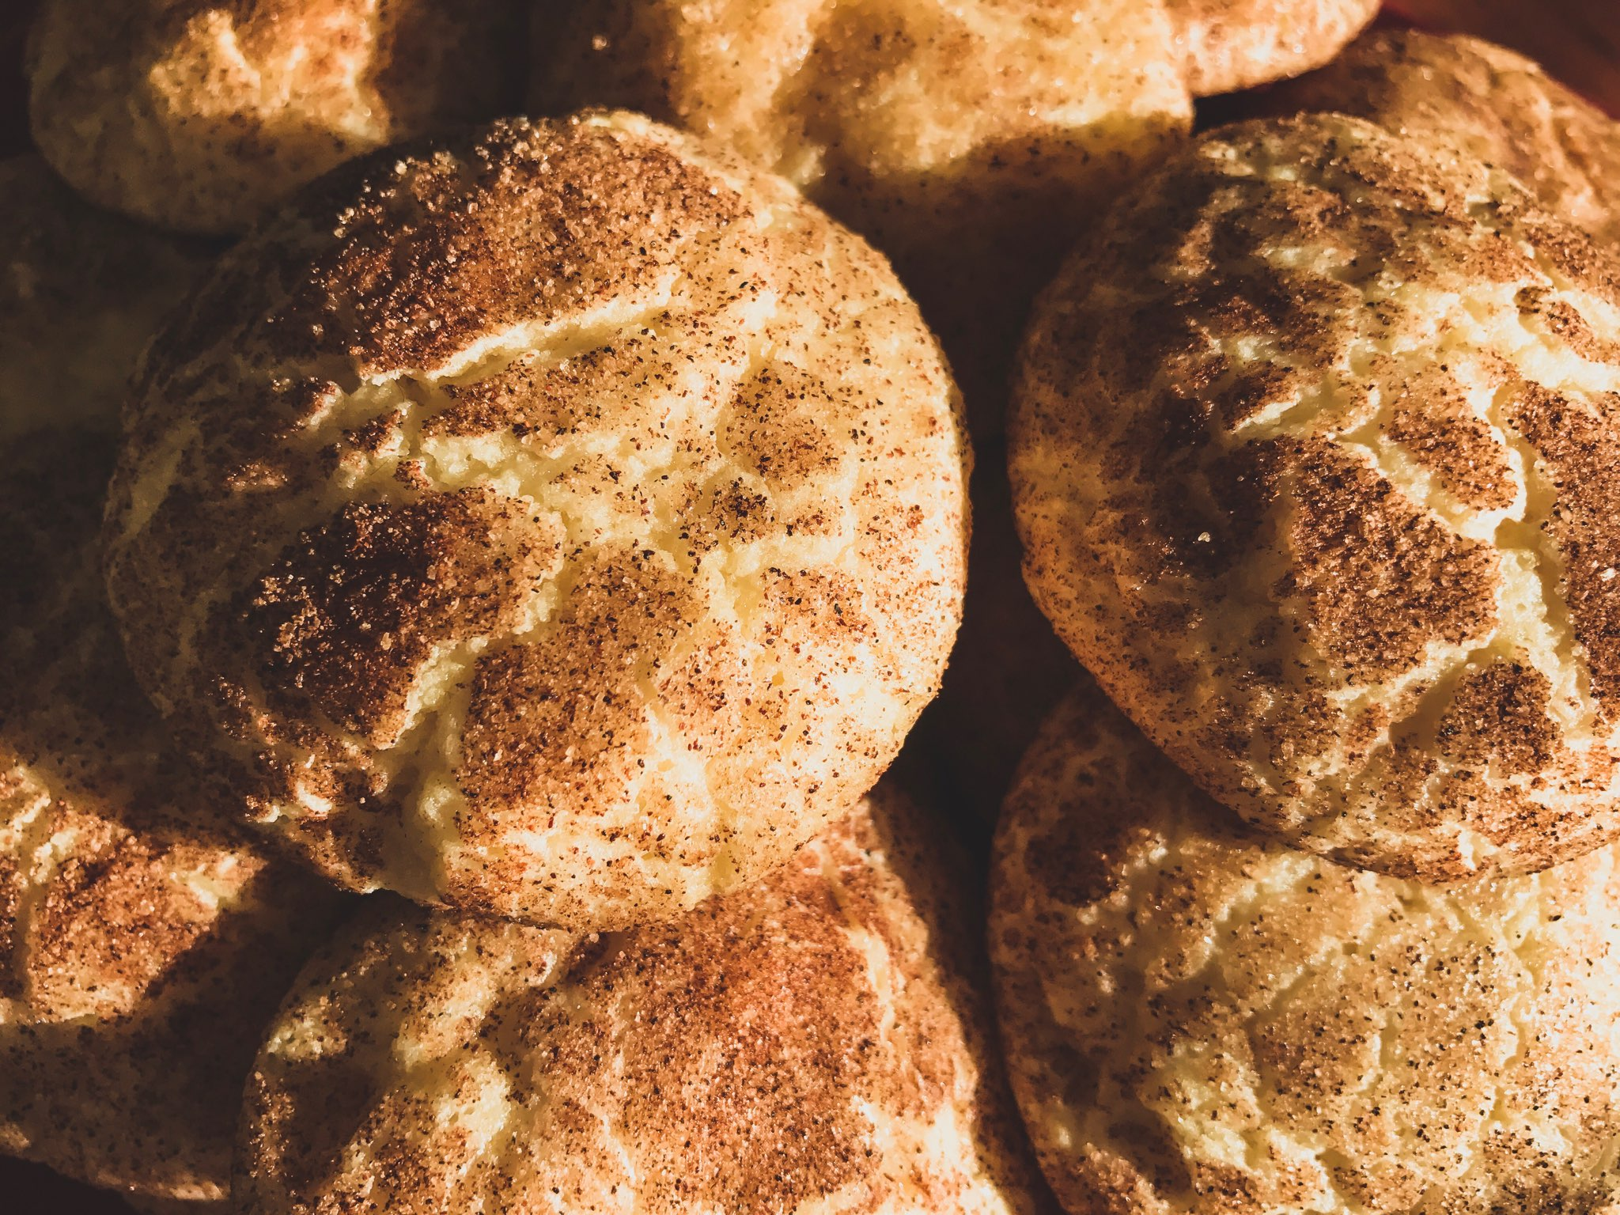  The Society of physics students  BAKE SALE  Everything is just a $1.00!  We hope you will join us as we tempt your pallet with the most delicious array of sweets and treats. Try our various types of cookies, cupcakes, rice krispies, muffins, and more! You are sure to be delighted! We look forward to seeing you there supporting the TAMUC Physics department!   | Snickerdoodles  ────  Rice Krispies  ────  Brownies  ────  Chocolate Chip Cookies  ────  Cupcakes  ────  Sugar Cookies  ────  Oreo Truffles ────  Plus, A LOT more!  Mcfarland science building  Location: Foyer  Date: Wednesday the 16th &  Thursday the 17th  Time: 8 a.m. – 4 p.m.

