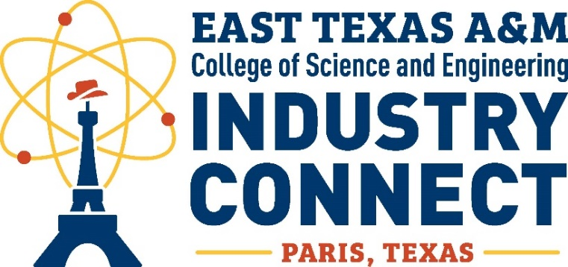

Theme: “The Future of Work in the Age of AI”

Date: November 7th

Time | Agenda Item
8:00 – 8:30 a.m. | Continental Breakfast & Networking Mixer
8:30 – 9:00 a.m. | Opening Remarks  - Maureen Hammond, CEcD, Executive Director, Paris Economic Development Corporation  - Dr. Andrea Graham, Dean, College of Science and Engineering
9:05 – 9:25 a.m. | Campbell’s Presentation
9:30 – 9:50 a.m. | TxDOT Presentation
9:55 – 10:15 a.m. | Harrison, Walker & Harper (HWH) Presentation
10:20 – 10:40 a.m. | Huhtamaki Presentation
10:40 – 10:50 a.m. | Break
10:50 – 11:30 a.m. | Roundtable Discussions & Networking – Use of AI and Emerging Skill Sets
11:30 a.m. – 12:40 p.m. | Luncheon & Keynote Address  Keynote Speaker: Erika Kemp, Strategic Initiatives & Innovation Director, Texas Department of Transportation
12:40 – 1:40 p.m. | City of Paris Tour
1:40 – 3:40 p.m. | Facility Tours
Location: Home2 Suites, 3143 NE Loop 286, Paris, TX 75460


