**Information below includes the due date for the Fall 2024 (16 weeks) semester, instructions, and the Administrative Drop form.**
Administrative Associates - please forward this email on to your faculty.

PLEASE NOTE: reporting students for nonattendance will NOT Drop them from your course. An Administrative Drop form will need to be completed and submitted to the Registrar’s Office for processing. Census Day is the deadline to receive a refund of charges, if the student is dropped from your course. After Census Day, students will receive a ‘Q’ grade, to denote the Drop, and zero (0) refund of charges. As a reminder, administratively dropping students from your class is NOT required.
Census Day, for the 16 weeks term, is September 11, 2024.

~~~~~~~~~~~~~~~~~~~~~~~~~~~~~~~~~~~~~~~~~~~~~~~~~~~~~~~~~~~~~~~~~~~~~~~~~~~~~~~~~~~~~~~~~~~~~~~~~~~~~~~~~~~

Instructions for submitting Census Day Rosters are as follows:
- Login to your myLEO
- Select the ‘Apps’ tab
- Select Census Day Roster

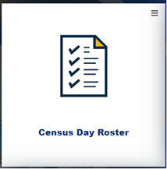

- Choose your course by clicking ‘Select’
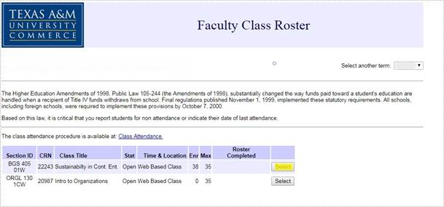

- Select ‘Never’ OR ‘Yes’ for each student on the Class Roster
  - NOTE: D2L’s ‘Class Progress’ option will indicate attendance/participation.

- Click the check box above the ‘Acknowledge’ button at the bottom of the Class Roster and select ‘Acknowledge’
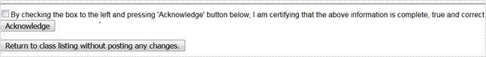

- If the Census Day Roster saved correctly, your screen will look like this:
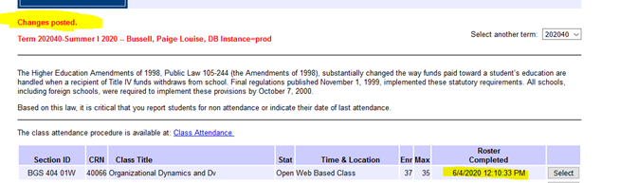

We appreciate your willingness and assistance in completing the Census Day Rosters, indicating whether or not students have attended your course. This information is important for reporting, financial aid and student enrollment appeals.

