Supplemental Links and Information

MSW Orientation Recording for Spring 2026
Recording-1(173 MB)
https://tamuc.zoom.us/rec/play/l_sVdCSHJxBFlgF3Wby_SHsL06F3FMQz_2BnleX4uCm62fRsvqlh1Er3AFQJHnA6rsj1YpDRP2iIfKyH.Tx2lTV3Ew-sLSI9Z

Passcode: RqagH8?h

TK20 Purchase (Mandatory Purchase)
https://payment.tk20.com/ctpayment/options_menu.do;jsessionid=2D2345DD9CA26E4F755EB7157C368098

Agency Contact Sheet – (Student completes)
https://dms.tamuc.edu/Forms/Student-Field-Instructor-Agency-Contact-Form

Agency Partnership Application (Agency Completes)
https://dms.tamuc.edu/Forms/Field-Education-Agency-Application

You can view the list of current agencies at the following link:
https://docs.google.com/spreadsheets/d/1C-WUbejd391uCdunjVEy00Bz5Fbw_7w2bqajHQ-QUmg/edit#gid=1247405936

*If your agency is not listed in the link above, please have the agency representative to complete the Agency Partnership Application

DALLAS AREA – Agency Spotlight

After 8 to Educate
https://after8toeducate.com/

Contact: Rosemary@after8toeducate.com
469.914.1700
______________________________________________

 | Leslie Vallarta, LMSW, LCDC-I  Manager | Quality Assurance Team  2121 Main St Suite 100, Dallas, TX 75201
Potential Remote Placements
Leslie Vallarta <lvallarta@ipsrecovery.com>

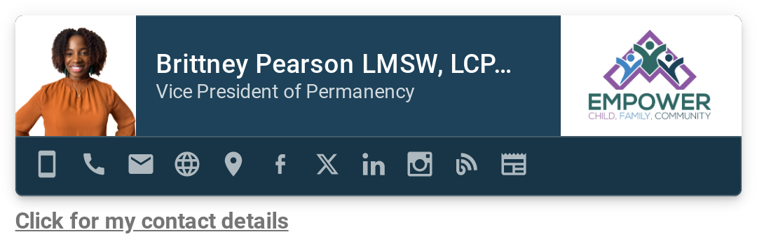
Brittney Pearson
bpearson@3empower.org

