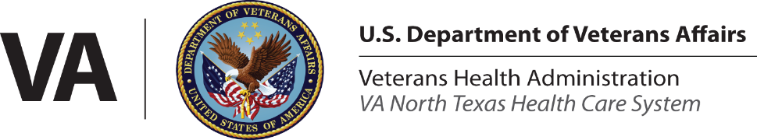

Social Work Intern Program Application
(Must be done electronically)

Date:

Name: Contact Number:

Email Address: Academic Institution:

Degree and Anticipated Graduation Date:

Type of Internship: ☐Block (40-hour week) ☐Split (16-20 hours week)

Advance Standing Student (2nd year MSW or accelerated w/ BSW): Yes ☐ No ☐

Where did you complete your prior internships (including BSW, if applicable):
Click or tap here to enter text.

Top three areas of interest:
*Note: Listed interests does not guarantee a spot within that department. Selections are based on a multitude of factors.

Location interest, please select one:
*Note: Location selections are not guaranteed, as they are dependent on preceptor availability.

☐Dallas | ☐Fort Worth/Grand Prairie
☐Bonham | ☐Sherman/Greenville/Tyler
☐Garland | ☐Plano
☐Denton | ☐Decatur/Granbury

Are you employed? Yes ☐ No ☐
Current employer:
*Note: Internship hours are subject to the preceptor’s hours and availability. After hours/weekend work is extremely limited.

Answer the following questions in paragraph form:

- Do you have prior experience completing psychosocial assessments? If so, how comfortable are you with them?
Click or tap here to enter text.

- Have you lead any type of clinical work, including, but not limited to: groups, individual sessions, etc.? If so, please describe the experience. If not, would you feel comfortable being in a clinical setting; why or why not?
Click or tap here to enter text.
- Describe your previous social work experience with clients, including what populations you’ve worked with, what interventions you’ve implemented, and any other relevant skills and abilities you possess.

Click or tap here to enter text.

Provide a two-page APA formatted essay attached to this application answering the following question:
Describe a situation in which you had an ethical difference with a colleague or supervisor; how did you respond, what did you learn, and what if anything would you do differently?

Please make sure the following are attached to the application and initial beside each confirming acknowledgement:
☐ Resume
☐ Ethics Essay
☐ One reference letter by someone who can attest to your social work knowledge, skills, and abilities

Click or tap here to enter text.
Applicant Signature/Date

Submit application and your resume via scan/email to: NTXSWICONBOARDING@va.gov

Submitted applications do not guarantee an internship with the VANTHCS. All intern selections are at the discretion of the Social Work Intern Coalition (SWIC) and Social Work Service (SWS) leadership.

