VA North Texas Health Care System
SOCIAL WORK
2025 CAREER DAY
Tuesday, March 25, 2025
9:30 AM – 1:00 PM
Dallas VA Medical Center (Atrium, Bldg 2J)
4500 S. Lancaster Rd., Dallas, TX 75216
REGISTRATION
Date: __________________________
Name: _____________________________________________________________
Address: ___________________________________________________________
Phone Number: __________________________
Email Address: ______________________________________________
University/College Name: ____________________________________________
Student Classification: __________________________________
Projected Graduation Date: ___________ Graduation Date: ___________
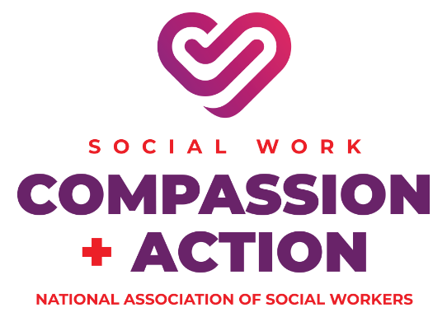
Please submit your registration form: Sherry Fairchild, PhD, LCSW-S, LMFT, LPC-S Program Coordinator Social Work Education
VA North Texas Health Care System
Sheryl.Fairchild@va.gov
VA Cell: 682-393-8679
