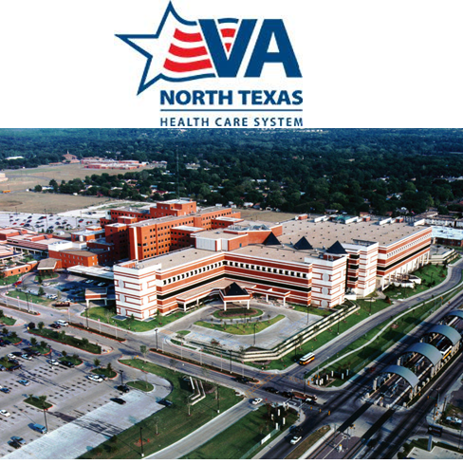
2023-2024 INTERPROFESSIONAL
SUBSTANCE USE DISORDER FELLOWSHIP

The Mental Health Gold Team at
VA North Texas Health Care System in Dallas, Texas
announces two openings for Post-Master’s Social Work Fellows.

The social work fellowship position is embedded in the Mental Health Gold Team. Selected fellows will be supervised by a clinical social worker and offered an opportunity to participate in LCSW clinical supervision, if eligible. The tour of duty will be 7:30 am – 4:00 pm.

The Mental Health Gold Team is a multifaceted interprofessional clinical team that specializes in providing mental health care to veterans who has a substance use disorder as their primary diagnosis. Most veterans engaged in care also have co-occurring psychiatric disorders, which may include affective disorders, trauma related disorders, anxiety disorders, psychotic disorders and/or personality disorders. The Gold Team is comprised of a 40-bed residential rehabilitation treatment program, intensive outpatient treatment program, opioid replacement clinic, and outpatient substance use disorder clinic.
The fellow will assess and treat Veterans in the residential rehabilitation treatment program and outpatient substance use disorder clinic. Within the residential rehabilitation treatment program, the fellow will facilitate psychoeducational groups such as relapse prevention, coping skills, co-occurring disorders, etc. Additionally, the fellow will be assigned as a primary clinician to veterans participating in the residential rehabilitation treatment program. As the primary clinician, the fellow will follow a veteran through the rehabilitation treatment process and conduct assessments, provide individual therapy, and coordinate their care with the interdisciplinary treatment team. The interdisciplinary team is comprised of psychiatrists, psychologists, physician assistants, nurses, social workers, addiction therapists, occupational therapists, nursing assistants, chaplains, a medical internist, pharmacist and peer support specialist.
Within the outpatient clinic, the fellow will assess, treat and coordinate the care of veterans who have substance use and co-occurring psychiatric disorders by providing follow-up care, individual and/or group psychotherapy, crisis intervention and social work interventions. The fellow will also have the opportunity to learn an evidenced based psychotherapy under the supervision of a trained licensed independent provider and complete a rotation in the Opioid Replacement Clinic.
Our primary goal is to provide fellows advanced training to develop effective skills in the field of social work and specialized clinical skills in substance use and co-occurring psychiatric disorders. Fellows will spend approximately 75 percent of their time in direct clinical care activities. The remaining 25 percent of their time will be in training activities such as diagnostic case studies, process recordings, general didactic seminars, substance use disorder didactic seminars and fellow case presentations. The fellow will be expected to present a case presentation and substance use disorder didactic seminar, both of which will be evaluated by a multidisciplinary panel of staff.

INTERPROFESSIONAL SUBSTANCE USE DISORDER FELLOWSHIP
Summary of Benefits and Application Requirements

Appointment: Fellowship, not to exceed 1 year (August 2023 – August 2024)

Stipend Amount: $33,657 Annual Basic Pay

Benefits:
- Health Insurance
- Annual and Sick Leave
- Paid Federal Holidays
Application Deadline: May 1, 2023
*Late applications will be considered only for positions that are not filled by applicants who applied by the deadline

Fellowship Eligibility:
- Be a US citizen
- A master’s degree in social work from a graduate program accredited by the Council on Social Work Education
- LMSW licensure preferred, but not required
Required Documents:
- Letter of interest that describes (a) why you are interested in further training in this fellowship, (b) prior exposure to recovery-oriented services for substance use disorders and/or serious mental illness, and (c) your long-term professional goals. Letters of interest are typically one page.
- A current resume
- Graduate transcripts (unofficial transcripts are acceptable at the time of application. If you are offered an interview, official transcripts will be required at a later date).
- Three letters of recommendation, one of which must be from a practicum supervisor
- Writing sample of your choice
All application materials should be submitted as a complete packet to: jennifer.roberts14@va.gov

Complete application packets will be accepted until the respective deadline. Should you have questions about the program or application requirements, please do not hesitate to contact me. We appreciate your consideration!

Jennifer Roberts, LCSW, BCD
Clinical Director, Mental Health Gold Team
Coordinator, VANTHCS Social Work SUD Fellowship
VA North Texas Health Care System
4500 South Lancaster Road
Mental Health Service, #116A
Dallas, Texas 75216

Office: (214) 857-4279, option 4
Email: jennifer.roberts14@va.gov

