Creating a non-VA TMS account:

Instructions for the Conference Attendee:
A non-VA user can go to the TMS homepage (https://www.tms.va.gov/secureauth35/) and click Create New User to set up a TMS profile. If you’ve previously created a TMS account, please contact VATMSHelp@va.gov
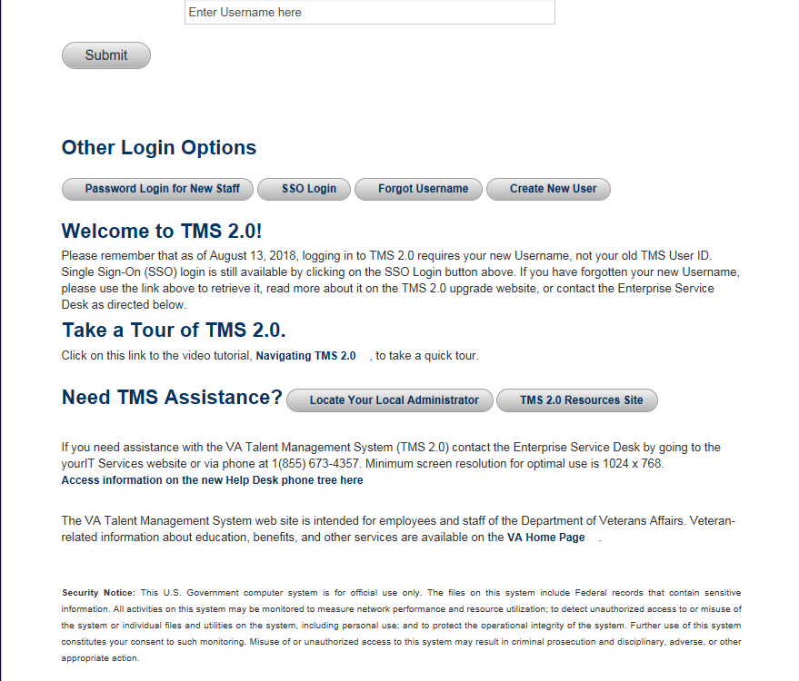

The user will select Veterans Health Administration (VHA) and click Next
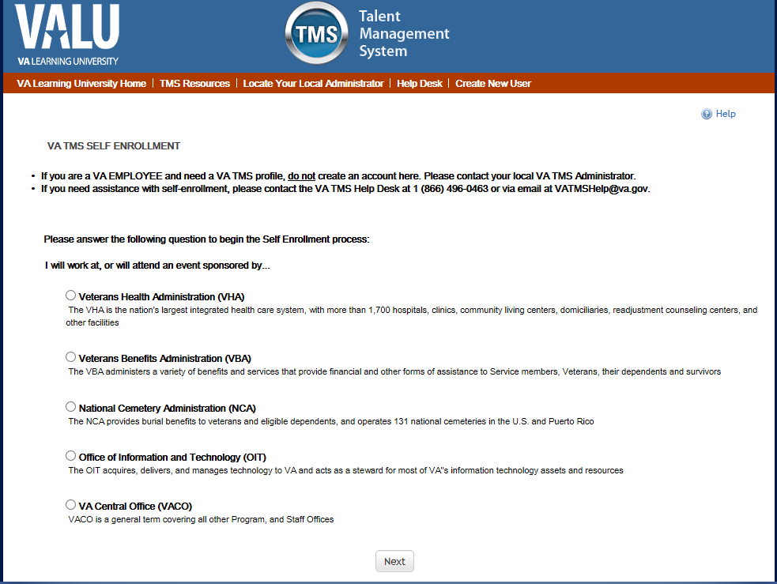
The user will select Conference Attendee (Those attending a VA-sponsored conference and click Next
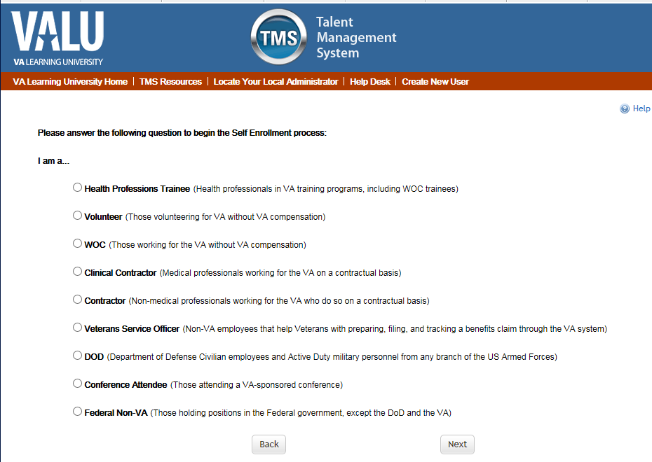
The user will fill in the required fields for their account information and conference information then click Submit
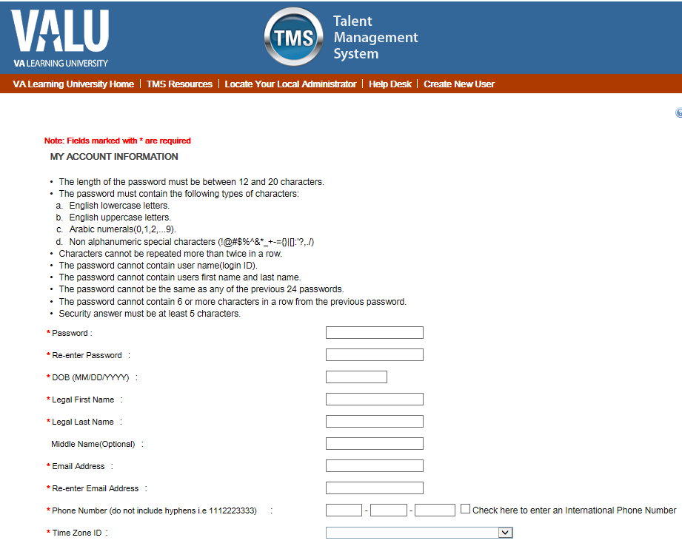

The VA Location, VA Point of Contact and all conference information will be provided to you.
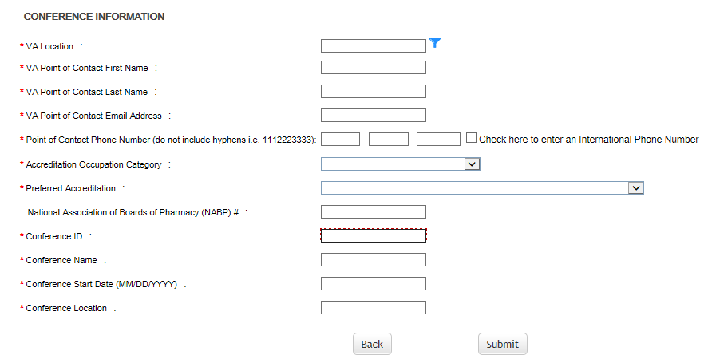

Once the user submits their information the following message will display. Click Continue to proceed.
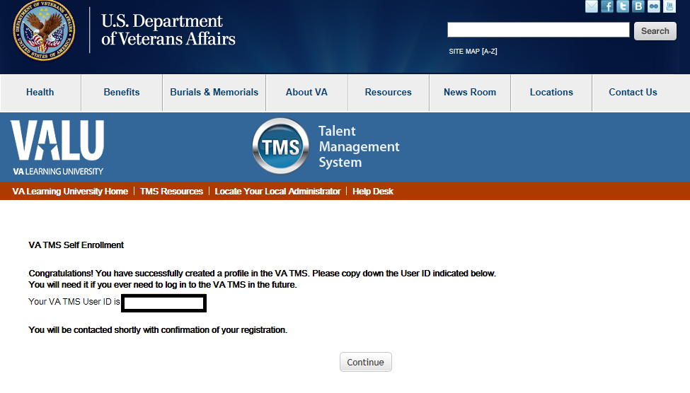
The user will be prompted to set up security questions. After setting up the security questions click Save
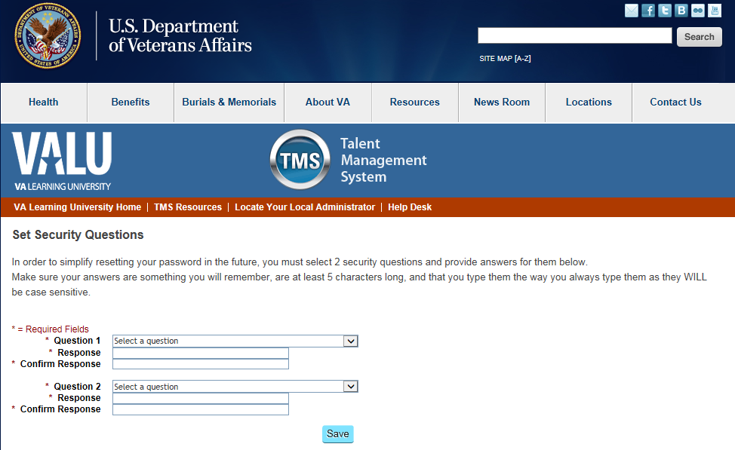

The user will be brought to their TMS homepage. Their account will look empty until the account has been validated by your local TMS Admin, the MSE role.
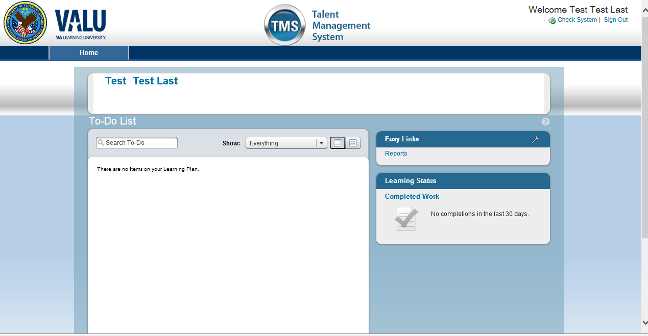

Instructions for the AIPs:
- You will provide the VA Location – this is your domain, e.g., WNY, MIN, SFC, VA Point of Contact and Conference Information (Scheduled Offering number, Title, Start Date, and Location of the conference) to non-VA attendees before they begin the self-enrollment process.
What happens after the conference attendee self-enrolls?
- A notification will be sent to the VA point of Contact that the user listed when setting up their profile.

Sample email:
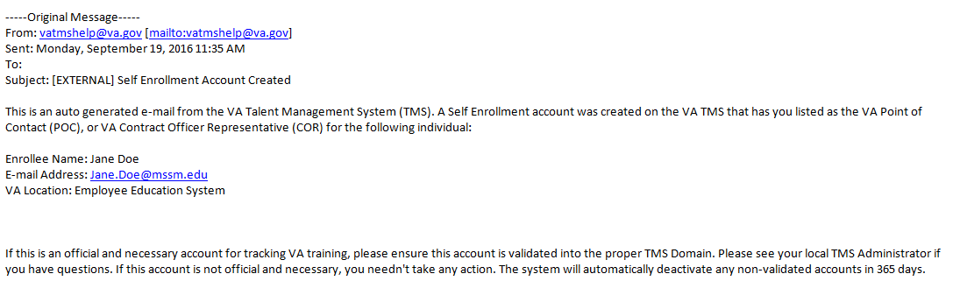

- Once you receive a notification email, please forward it to the your local TMS Admin
- Someone from your site team will validate the account and email you once it has been validated.
- Upon receiving an email that the users profile has been validated, you can now register the user for the scheduled offering they wish to attend.
- Once the user has been registered, the course will show on their to-do list in TMS.
- The user will now attend the training, complete the content, take the evaluation, and proceed to print their certificate.

