interoffice memorandum
to: | BSw & msw students
from: | alexis nixon, president of the “a” team
subject: | student kitchen
date: | October 15, 2012
cc: | pam hammond
Dear Students:
It has come to my attention recently that we have had quite a bit of issues regarding the cleanliness of our Student Kitchen. This afternoon I too had the misfortune of seeing unnecessary filth left behind by fellow students. It is important to remember the importance of valuing our rewards such as the Student Kitchen. By providing us a kitchen, the Social Work Department has provided us with a sink, utensils, a coffee machine, microwaves and more to accommodate our lunchtime hour.
This afternoon, I spent time cleaning this kitchen and discovered many disastrous things. First, there was a molded pot of copy left behind for an uncertain amount of time. Also the kitchen was dirty from countertops, sink and more. Our poor coffee filter had never been cleaned, and was very filthy itself. I happened to notice a very large crack in the pot therefore we will allocate A Team funds to buy another pot. We are also in need of cleaning material and I will be obtaining that as well.
I have attached pictures to show the damage that was cleaned earlier. I encourage you all to look for complete understanding. Please take this email as a friendly encouragement as I would hate to see the kitchen like this again or to possibly lose the kitchen due to its uncleanliness.
Thanks for your time,

Alexis Nixon
President of The “A” Team

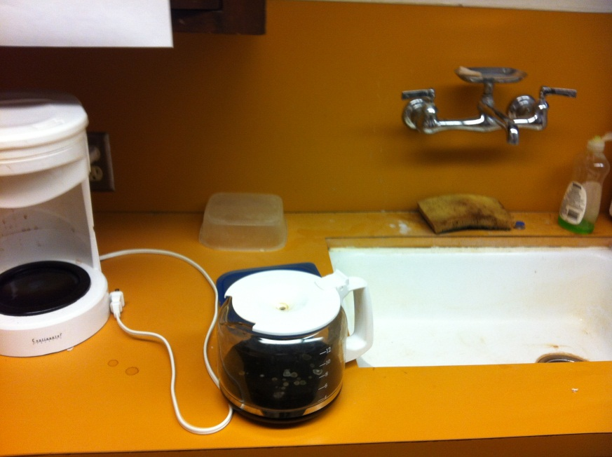 Before

After:


