How to Upload New Syllabi

- Open your Firefox, Google Chrome, or Safari Web browser. Cascade is not compatible with Internet Explorer.
- Type cms.tamuc.edu:8080 in the address bar and press Enter.



- Log into Cascade.

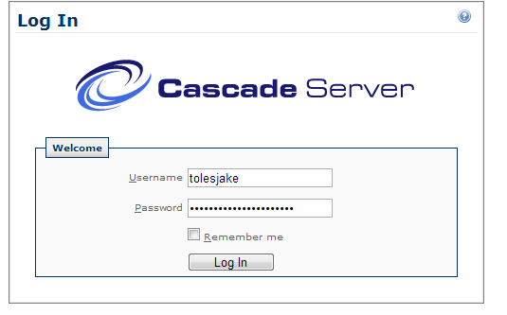
- Click _Common > New > CV and Syllabi > Syllabi. Click the term that you are uploading syllabi for.


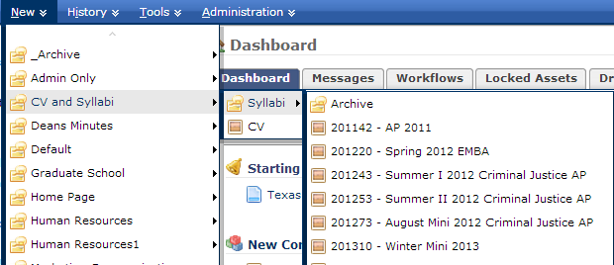

- Click on Choose File, browse to the syllabus PDF file you have saved then click Open.
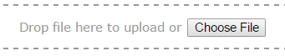
- In “System Name”, the CRN file will be automatically entered. Ex. 80003.pdf
- Make sure Parent Folder points to that the path to store the syllabi is located in ACADEM:academics/cvSyllabi/syllabi/2015xx*. If the Path is not correct, click on the yellow folder next to Parent Folder and click on Browse.
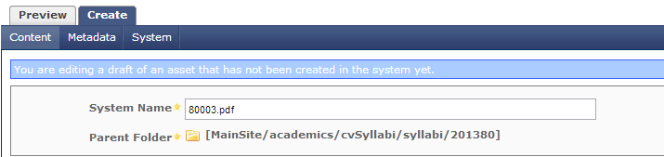

Note, if the file is not named correctly, you will see an error message after you have submitted the file as shown below. Check that the extension ‘.pdf’ is not capitalize or there are spaces in the file name.

- After you have clicked on the yellow folder by Parent Folder, a dialog box will open. Proceed to select ACADEM from the pull down menu.
- Expand academics, cvSyllabi, syllabi folder by clicking on the plus icon
- Select the term folder syllabi will live in.
- Click on the Confirm button.
- Click the Submit button.
- Click the Publish tab and then click Submit.

When will you see the Syllabus in Schedule of Classes?
If you have just uploaded and published a syllabus, you will not see it in the schedule of classes right away. The schedule of classes updates its syllabi listings nightly, so check the next day to verify that your syllabus has been added. If not, contact the help desk at 903-468-6000 for assistance.

