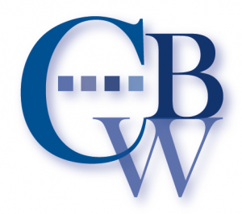
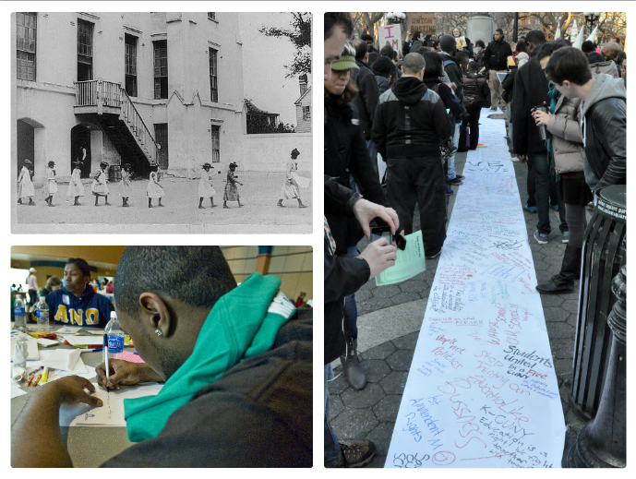
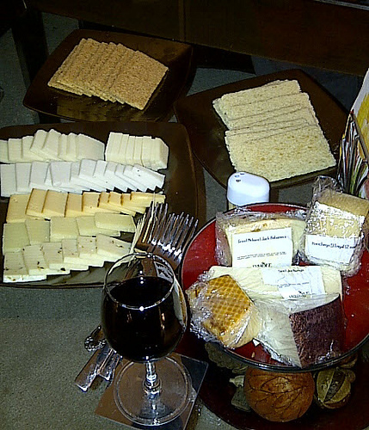
Image Credits via Flickr: hdes.copeland, pennstatelive, Michael Fleshman, and Meetusinghal

Join us for the CBW Special Interest Group (SIG) TSIG.04 on Mar 15, 2013 from 6:30 PM to 7:30 PM.

Many Basic Writing sessions will be live blogged on http://cbwblog.wordpress.com

A listing of Basic Writing sessions at CCCC is available on the CBW blog and on the Facebook group.

More Basic Writing at CCCC 2013:
- The CBW Blog at http://cbwblog.wordpress.com
- Our Facebook Group, “Council on Basic Writing”
- An electronic journal for Basic Writing: BWe at http://orgs.tamu-commerce.edu/BWE/
- The Journal of Basic Writing at http://wac.colostate.edu/jbw/
- An annual pre-conference workshop and special interest group meeting at the Conference on College Composition and Communication.
- The CBW-L is a listserv focused on basic writing and related issues. To subscribe to this listserv, send an e-mail message to: listserv@umn.edu. The content of the message should read subscribe CBW-L firstname lastname. For example, write subscribe cbw-l jane doe. You should leave the subject line blank and remove your signature for this message.
- A bibliography of research and best practices in Basic Writing, published by Bedford/St. Martin’s.

The Conference on Basic Writing (CBW), founded in 1980 by Charles Guilford and Karen Uehling, unites Basic Writing educators from across the country. In 2010, CBW changed its name to Council on Basic Writing. Today, the CBW functions as a special interest group of the Conference on College Communication and Composition. We meet annually at the CCCC meeting, hosting workshops and interest group meetings. Our current co-chairs are Sugie Goen-Salter and J. Elizabeth Clark.

Basic Writing and Race: A Symposium

The Council on Basic Writing Presents:
2013

Connect

  - 13 March 2013/CCCC/Las Vegas, Nevada
Image by: Meetusinghal
Image by: Meetusinghal

1:00-2:30 ~ Race, Language, and Access: Possible Futures of Basic Writing

Steve Lamos & Wendy Olson, moderators

Featuring: Scott Lyons, Beatrice Mendez-Newman, Min-Zhan Lu, and Shirley Faulker-Springfield

An interactive roundtable addresses the following themes: BW and whiteness; the role of BW in Minority-Serving Institutions (MSIs); race-conscious BW pedagogies; BW and “Generation 1.5” students; and other related issues. Speakers will offer brief responses to one theme, then move to facilitate a small group discussion. In closing, small groups will report back to the larger group with observations and/or suggestions for future directions.

2:30-4:00 ~ Publishing & Grant Writing Workshop

Hannah Ashley, “5 Ways In...Tricks of the Trade to Get Yourself Published”

Susan Naomi Bernstein, “"The Nice White Lady Writes About Race: Revising Teaching Developmental Writing 4e."

In this session, workshop participants are invited to bring ideas for articles, abstracts, and grants. Break out groups with published mentors will work to assist participants with publishing and grant questions and concerns.

4:00-5:00 ~ Public Work and Local Contexts

Greg Glau and Lynn Reid, moderators

This last segment of the day will focus on small group networking, helping basic writing educators to make connections.

5:00-6:30 p.m. Immediately following the CBW Workshop, please join us for a Wine, Cheese, and Technologies Reception sponsored by Pearson and CBW. Our thanks to Pearson!

Image by: Meetusinghal

9:00 ~ Welcome & Opening Remarks

J. Elizabeth Clark

9:15-10:00 ~ Toward a Political Economy of Basic Writing Programs

William Lalicker, moderator

Victor Villanueva, Keynote Address

One way to define “political economy” is to consider the relations between economics and systems of power, like decision-making bodies. Basic Writing programs have always been subject to rhetorical, legislative, and economic conditions in the ways that traditional first-year programs have not. Villanueva will discuss the rises and falls of basic writing programs from the perspective of political economics as it obtains in rhetoric, including his own experiences in keeping basic writing programs alive.

10:00-10:30 ~ Small Group Response to Victor Villanueva

~Break~

10:45-12:00 ~ Race, Locality, and the Public Work of Basic Writing

Sugie Goen-Salter, moderator

This session will focus on the public work of basic writing, with particular focus (broadly defined) on issues related to race, racial injustice and critical race studies. Working in small groups, participants will explore preparing and supporting students of color; preparing and supporting faculty of color; innovative programs; responding to local challenges; basic writing and race; basic writing and social inequality; basic writing and racial justice; meeting challenges and attacks on basic writing programs; and making the work of basic writing part of the public fabric of our communities.

12:00-1:00 ~ Lunch Break

Morning Agenda

Afternoon Agenda

