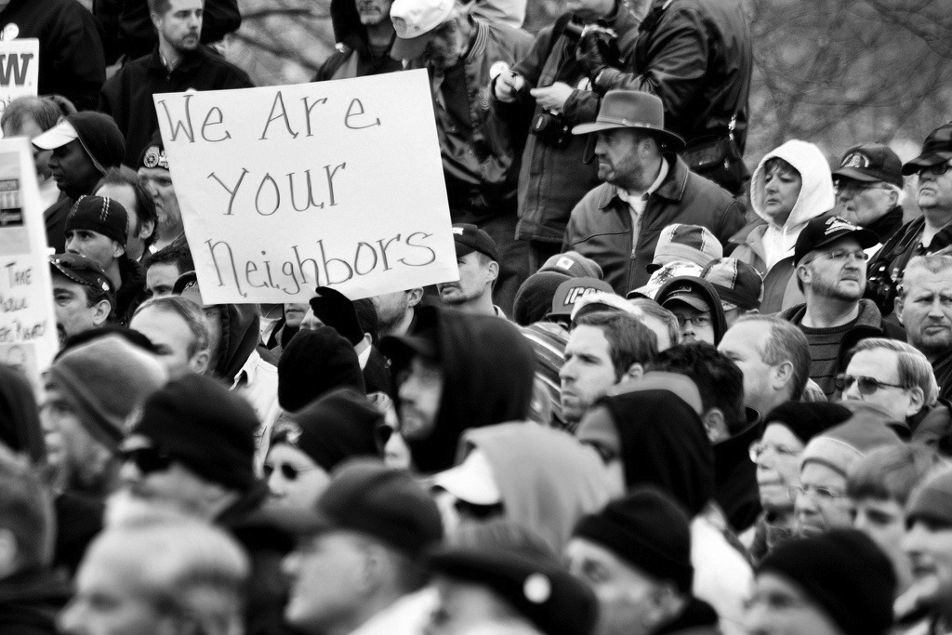
by Phil Roeder, 2/11/2011, East Fork, Des Moines, IA. Photos from the We Are One Rally in solidarity with labor protests in Wisconsin and in support of public employees in Iowa. It was held on the steps of the Iowa State Capitol on February 22, 2011 and, depending on who you choose to believe, attended by 800 people (local newspaper) or 3,000 people (Iowa State Patrol).”

Creative Commons (CC), Some Rights Reserved (attribution)
CBW 2011 will overview the ways in which CBW must redefine its mission in the current milieu, while not losing sight of BW's core values, in order to acknowledge the multifaceted work of student support, retention, and diversity being performed by many contemporary BW programs. Facilitated discussion toward a new CBW mission statement will follow.

Strategic Coalition Building Across

(Contested) Spaces Serving Basic Writers

We Are Not Alone

Council on Basic Writing (CBW)
2011
Council on Basic Writing (CBW)
Blog: http://cbwblog.wordpress.com/
Facebook: CBW

Cover Image
CBW meets each year before CCCC for a day long workshop filled with presentations and interactive discussion toward concrete goals that support BW teachers and scholars across the country. In 2012, we will meet in St. Louis in response to the CCCC 2012 theme “Writing Gateways.”
St. Louis, Missouri, March 21-24, 2012.
  - Wednesday, April 6, 2011
  - Atlanta, Georgia

Join us in St. Louis in 2012!

CBW Mission Statement

4:30-5:00—Group Discussion
Toward Recommendations for CBW

3:00-4:30—Roundtable Discussions
The Local Matters: Defining “Basic” in Local Contexts
Kelly Ritter, University of North Carolina-Greensboro

2:00—Featured Presentation
Bryant, Student Support
Basic Writing among the Natives, or How to Change Survive a Program from the Inside, Michael D. Hill, Henry Ford CC

Shreyer, ?

1:00—Panelists and Discussion
Stating Our Mission
Steve Lamos, University of Colorado-Boulder

Coffee Breaks
@ 9:30 and 2:30

11:00—Workshop
Strategic Collaboration Across Disciplinary and Institutional Cultures: Coalition Building, Strategic Instruction, and Grantsmanship, Melissa Ianetta and Joseph Turner, University of Delaware

Another Open Admissions Context: BW in the 21st Century Community College, Wendy Olson, Washington State University

Building Campus Coalitions: A Case Study, Rachel Rigolino and Penny Freel, SUNY New Paltz

Recommendations for CBW

Setting the Stage: History and Future of Basic Writing
Mary Soliday, San Francisco State University
Rebecca Mlynarczyk, CUNY

9:45—Panelists and Discussion

9:00—Featured Presentations
Access to higher education has rarely been more important or more contested. In fact, colleges and universities across the nation find themselves no less vulnerable in this fight for dwindling resources than the struggling masses knocking at their doors. In many cases, BW programs are the first to go (Soliday 2002, 2004: Greene & McAlexander 2008; Otte & Mlynarczyk 2010). Long committed to serving writers otherwise denied admittance, such programs draw their very existence from increasingly contested spaces.
We are not alone. In fact BW's very survival may depend on an ability to recognize and build strategic coalitions across the same programs and services with which a great many of us now compete. These services often identify with core objectives shared by BW programs, including: serving the literacy needs of first-generation, minority and other underrepresented students and making campus environments more welcoming and supportive to those students; offering individual and small-group support designed to improve retention and graduation rates; offering instruction that both recognizes students' existing strengths and promotes intellectual and literate growth, helping students to meet linguistic "standards" while cultivating linguistic and literate diversity.
This workshop will explore "all our relations." When establishing responses to what appears to be the systematic dismantling of basic writing programs across the nation, how can we build strategic coalitions with those we already think of as "our relations" and, perhaps, those we might currently think of as "beautiful enemies"?

CBW 2011 is a working conference. Expert panelists will prompt participant conversation toward concrete recommendations for the future of the Council on Basic Writing, specifically in response to BW's increasing vulnerability. Featured Speakers and Panelists will alternate with interactive roundtable discussions designed to move the Council on Basic Writing toward greater focus on serving its current constituents as well as broadening those constituencies and helping those constituents cross institutional, communal and theoretical boundaries.

Schedule

Overview

