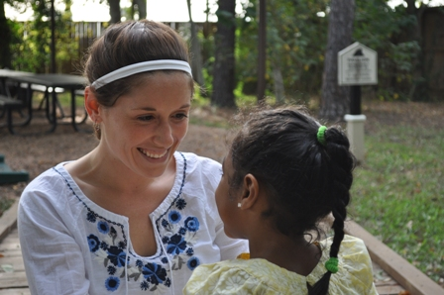  GAP YEAR OPPORTUNITY FOR GRADUATING SENIORS  hands of hope  What is this? This program typically lasts for one year and gives young adults the opportunity to care for children under the age of six years old at the time of placement who are currently in residential care with our agency.  What will I be doing? Everything necessary to properly and safely care for, advocate for and meet the daily needs of four to five children placed in your home.  Will I be doing this alone? The community is made up of ten homes in a gated neighborhood that have approximately four Hands of Hope House Parents in each home.  How will this help my future? This gives you the opportunity to earn hands on experience leaning how abuse, neglect, and the effects of HIV play a role in some of society’s most vulnerable children. You will be working directly with therapists, specialists, and social workers to meet the specific needs for each individual child. | SOCIAL WORK  ────  PRE-MEDICINE  ────  PSYCHOLOGY  ────  EDUCATION  ────  SOCIOLOGY  ────  HEALTH SCIENCES  ────  SOCIAL JUSTICE  cASA DE ESPERANZA  P.O. BOX 66581  Houston, TX 77266  713-529-9179  www.casahope.org  Person to Contact:  Darean Talmadge  Email: dtalmadge@casahope.org

