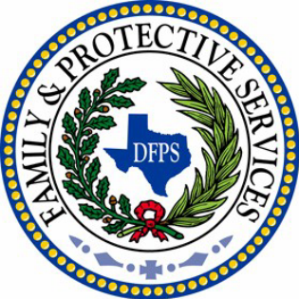
DFPS IS HIRING
You're invited to a
Recruitment Open House!

What: If you are interested in a challenging but rewarding career with the Department of Family and Protective Services in Dallas/Fort Worth and the surrounding areas, please join us for an informational open house!
When: Thursday, November 5th, 2:00pm to 4:00pm
Where: 801 S. State Hwy 161, Grand Prairie, TX 75051 (Lone Star Room - 2nd Floor)
Regional staff will be present to answer questions regarding positions available including:
- Child Protective Services
  - Investigations
  - Family Based Safety Services
  - Conservatorship
- Adult Protective Services
  - In Home Specialist
  - Facility Investigator
- Child Care Licensing
  - Child Care Licensing Investigator
  - Child Care Licensing Inspector
  - Residential Child Care Licensing Investigator
  - Residential Child Care Licensing Inspector
Hiring staff will also be present to answer questions regarding the application process, feel free to bring your resume!
**Minimum requirements include a Bachelor's degree from an accredited college. Interested applicants who are 60 days away from graduating are encouraged to attend.**
Spacing is limited to the first 25 people to RSVP.
Please RSVP no later than 10/30/15 to the email addresses below:

Sofia Barnes @ sofia.nicholson@dfps.state.tx.us or
Lindsey Matthews @ lindsey.matthews@dfps.state.tx.us

