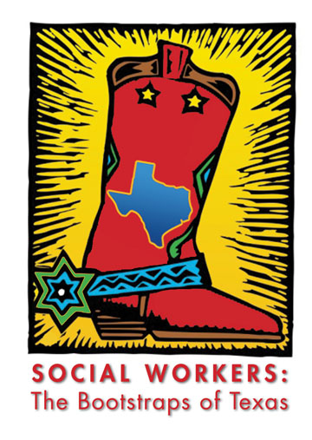

Social Work Young Professionals
Denton area launch meeting:
Monday, February 6th at 5:30 PM
at The Loophole.
119 W. Hickory St. Denton, TX 76201
Please join us to find out more about how you can be involved in this up and coming organization!
If you have questions or need help with directions, please contact Celes Galttana at 817-675-5936 or by e-mail at Celesgalttana@my.unt.edu or Brandi Felderhoff at 940.391.4071 or by e-mail at brandijgideon@gmail.com

