Study Abroad in Cuernavaca Seminars Begin This Week
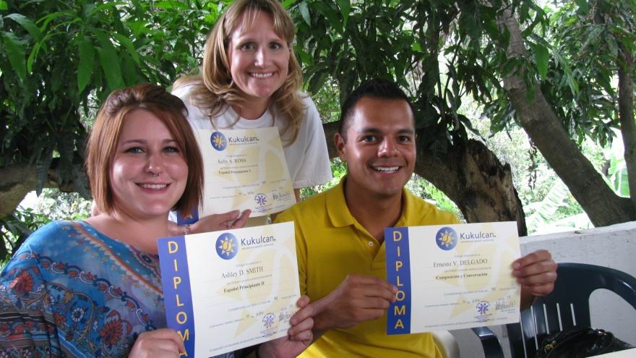
Dr. Green has begun the recruitment process for the 2011 Cuernavaca summer study abroad program. The three week program will leave for Mexico City on Sunday, June 12 and return to DFW on Saturday, July 2, 2011. Students will study Spanish daily, live with Mexican families, take a weekly field trip to a Mexican school or other institution relevant to students’ careers, participate in four all day weekend excursions to Mexico City and other near-by historical and cultural sites, and earn 3-6 semester hours of credit that will transfer to the university. The very reasonable price of $3,400 to $3,500 covers almost everything including airfare, room and board, and tuition. Participants should be eligible for financial aid as well as a merit scholarship from the International Studies Office.
If you want more information about this program, you must attend an official International Studies seminar before you can apply for any of the International Studies programs. Dr. Green is scheduling a series of seminars in addition to those offered by Dr. Clinton, International Studies Director, during the month of February that will specifically address the Cuernavaca trip as follows:
- Tues, February 22, 4:00 PM, EDS 134
- Wed, February 23, 3:00 PM & 7:00 PM, EDS 134
- Mon, February 28, 9:00 PM, MPX 205
Note that both undergraduate and graduate students can participate. Please come learn more about this unique opportunity, which previous participants have raved about.

